## CHAPTER 1: INTRODUCTION

* 1. OVERVIEW

According to the World Health Organization, depression is the leading cause of disability worldwide. Globally, more than 300 million people of all ages suffer from the disorder. And the incidence of the disorder is increasing everywhere. Depression is a complex condition, involving many systems of the body, including the immune system, either as cause or effect. It disrupts sleep and it interferes with appetite; in some cases, it causes weight loss; in others, it contributes to weight gain. Depression is also often accompanied by anxiety. Research indicates that not only do the two conditions co-occur but that they overlap in vulnerability patterns.

Because of its complexity, a full understanding of depression has been elusive. Researchers have some evidence that depression susceptibility is related to diet, both directly—through inadequate consumption of nutrients such as omega-3 fats—and indirectly, through the variety of bacteria that populate the gut. But depression involves mood and thoughts as well as the body, and it causes pain for both those living with the disorder and those who care about them.

Even in the most severe cases, depression is highly treatable. The condition is often cyclical, and early treatment may prevent or forestall recurrent episodes. Many studies show that the most effective treatment is cognitive behavioural therapy, which addresses problematic thought patterns, with or without the use of antidepressant drugs. In addition, evidence is quickly accumulating that regular mindfulness meditation, on its own or combined with cognitive therapy, can stop depression before it starts by diminishing reactivity to distressing experiences, effectively enabling disengagement of attention from the repetitive negative thoughts that often set the downward spiral of mood in motion.

Chrome browser is developed in a way where a person can surf through the internet in order to look for photos, videos, music, web series and many more websites reflecting their moods, feelings and sentiments. This creates an opportunity to analyze browser history data for user’s feelings and sentiments to investigate their moods and attitudes when they are surfing through the internet. Machine learning techniques identify high quality solutions of

mental health problems among social media users. Therefore, here machine learning techniques are used to classify a person’s mental health based on Browser History (Chrome).

* 1. OBEJCTIVES

As the society becomes more and more technically advanced, we are tuning more into the online world. But as a result, some people can feel more isolated and this can in turn increase the occurrence of anxiety and depression.

Ironically, some people turn to social platforms to outlet their thoughts and emotions, and platforms like chrome where they can access almost all the websites and facilities provided by the internet, which can entice the user to be more uninhibited in their expressions.

This offers an opportunity for emotional detection of users based on their search history. From the medical perspective, it provides a good opportunity to identify potential depression in the users and from there offer suitable support and assist them to a path of recovery, by introducing them to self-care chatbots such as landbot.io, that uses Cognitive Behavioural Therapy to help its users change their negative thought patterns, as well as providing friendship in their time of need.

We aim to provide a dataset that is specifically designed for depression identification based on browser history.

The goal of this report is to apply Natural Language Processing and Machine Learning techniques to build a system that given a set of browser searches from a user can identify at- risk content and hence at-risk users. For this task, we need to identify useful textual or community features. This system needs to take into account knowledge of browser searches such as:

1. The depressive or negative words used while searching,
2. Users search about a wide variety of emotions.

This leads to a secondary goal of the report, which is to identify only the last 1000 searches of browser. In this study, we aim to perform depression analysis on browser search data. To investigate the effect of depression detection, we would propose an NLP Tool that use machine learning to classify a person's mental health based on social platform searches (Chrome API) into 2 categories; depressed or not depressed. We report an implementation of the proposed method. We evaluate the efficiency of our proposed method using a set of various psycholinguistic features. We show that our proposed method can significantly improve the accuracy and classification error rate.

## CHAPTER 2: LITERATURE SURVEY

In this section, we discuss the previous works performed using various techniques for psychological analysis and the depression detection task.

Using linguistics in depression detection is quite useful as it shows that words used by non depressed and depressed people may differ. Depressed individuals mainly focus on themselves. In 2014, Nguyen studied two online discussion groups, namely, “control” and “clinical” groups. The “control” group comprised people with a similar interest and fun-loving people, whereas the “clinical” group comprised people suffering from mental illnesses such bipolar disorder, major depressive disorder, SAD, and anxiety attacks. People in the clinical group discussed their issues freely and took advice for medication and intervention. The author finds a difference in online communities involving people of these two groups. People in the “clinical” group usually use first-person pronouns (“I”, “me,” and “my”) in comparison with “control” group people, who use fewer first-person pronouns and discuss various activities such as dancing, singing, and running. This work reveals that use of language plays an important role in depression detection as words describe what someone’s current mental state is.

In 2005, Pennebaker used LIWC (Linguistic Inquiry and Word Count), a piece of dictionary software, for analyzing textual data to obtain meaningful insights. Detecting depression using Facebook comments and using 4 categories from the LIWC software to analyze words in the comments were the author’s objectives. These categories are language-based, time-based, or emotions-based or include all features. These factors have all minor characteristics of human language use and conditions such as related emotions, time periods, and use of nouns to find out the very meaning of human speech. Using the KNN (K-nearest neighbour) machine learning algorithm for classification, an accuracy of 65% was achieved.

In 2019, Gaikar used SVMs (support vector machines) and Naïve Bayes classifiers to detect depression-related words and sentences and detected the types of depression from those identified words. The authors trained both the classifiers using the bipolar disorder dataset and depression illness–related dataset. The best accuracy achieved was 85% using a machine learning classifier. In [2], the author used audio and text-based data. These data play an important role in natural language processing, and they range from images, texts to videos, and small clips. With text data, the information is limited, but with the audio of depression survivors, it is easy to understand some facts about the affected person’s body language. A total of 142 individuals underwent depression detection tests by being asked some questions. They recorded the answers in audio forms and text forms directly from the 142 people, and feature extraction was carried out using the long short-term memory model. The results show that people with depression use more pauses than non-depressed persons and that using first-person pronouns is common among depression survivors; however, nondepressed persons use fewer pauses while talking and focus less on them.

In [3], the author used the Twitter platform to conduct the task of identification of depression using text-based data as Twitter provides short and useful linguistic phrases that directly shows the current mental state of the user. The data were gathered from the CLPsych 2015 conference in which the latest 3000 public tweets are available. For feature extraction, the author used the

bag-of-words approach that is famous for identifying mental health illness using machine learning. The method shows word frequencies and the number associated with them and applies various machine learning classifiers in which Naïve Bayes/1-gram gives a recall value accuracy of 86% with 82%, respectively.

Reference [4] focuses on early detection of depression using neural networks. Depressive disorder has various stages, which include initial, intermediate, major, and severe disorders. The initial level of depressive disorder includes visibility of symptoms appearing in affected people such as low appetite, feeling of suicide, social inferiority, and comparing themselves with others. The author suggests identifying depression at its initial stage where it is less harmful is easily curable. Using CNNs (convolutional neural networks), behavioral characteristics from text-based data (CLPsych) are extracted, and some improvements in the early detection parameter ERDE are introduced.

In 2018, Lang used speech data to detect depression, proposing a deep convolutional neural network to process speech-based data. Authors use secondary datasets such as AVEC2013 and AVEC2014 depression datasets that comprise 340 short videos of 292 selected people. These data were collected through human beings and computer system interactions using webcams and microphones. The model gives an RMSE value of 9.0001 and an MAE of 7.4211. In Ref. [5], the author analyzed Facebook comments data using various machine learning algorithms. Facebook contains plenty of data that comprise videos, images, and text-based data. Using only text-based data from comments of various publicly available pages, the author analyzed them using machine learning classifiers such as decision trees, KNN, support vector machines, and ensemble classifiers, in which decision trees achieved the best accuracy of 73%.

In Ref. [6], the researchers focused on mood analysis of human beings with the help of machine learning and deep learning tools of artificial intelligence. In this paper, authors also focused on limitations of artificial intelligence to detect depression.

In Ref. [7], the author implemented a machine learning model with pre-processed data for automatic depression classification. Kinect captured a skeletal model used for data extraction and pre-processing. The model achieved 96.47% accuracy in the old-age group and 53.85% accuracy in the young-age group.

In Ref. [8], the authors carried out a prediction of depression by noticing the human behavior. For prediction, authors used smart phone datasets. The model achieved 96.44%–98.14% accuracy.

In Ref. [9], the researchers implemented an automatic depression detection [AUTO DEP] model by using facial expressions of human beings. The authors used a linear binary pattern descriptor model for feature extraction. The performance of the automatic depression detection model is the same as that of usual previous models. The evaluation of the model was performed on MATLAB and the linear binary pattern descriptor FPGA using Xilinx VIVADO.

## CHAPTER 3: SYSTEM REQUIREMENT

* 1. HARDWARE REQUIREMENTS
     1. LIST OF HARDWARE REQUIREMENTS
        + Processor: Above i3
        + Speed: 1.1 G Hz
        + RAM: 8 GB (min)
        + Hard Disk: 20 GB
        + Graphics Card: Latest version of Graphics Card
     2. HARDWARE DESCRIPTION

1. Processor:



Fig 1: Processor

A processor (CPU) is the logic circuitry that responds to and processes the basic instructions that drive a computer. The CPU is seen as the main and most crucial integrated circuitry (IC) chip in a computer, as it is responsible for interpreting most of computers commands. CPUs will perform most basic arithmetic, logic and I/O operations, as well as allocate commands for other chips and components running in a computer.

The term processor is [used interchangeably](https://searchservervirtualization.techtarget.com/tip/CPU-vs-microprocessor-What-are-the-differences) with the term central processing unit ([CPU](https://www.techtarget.com/whatis/definition/processor)), although strictly speaking, the CPU is not the only processor in a computer. The [GPU](https://www.techtarget.com/searchvirtualdesktop/definition/GPU-graphics-processing-unit) (graphics processing unit) is the most notable example, but the hard drive and other

devices within a computer also perform some processing independently. Nevertheless, the term processor is generally understood to mean the CPU.

1. Speed:

With technology, increased productivity goals, faster internet, and more devices, we’ve created a need for speed wherever we go. We’re used to getting results instantaneously and expect our devices to keep up with our requests as we multi-task our way through life.

Computer processors and their clock speed are two features we most commonly associate with high-performing, fast technology.

Computer processor speed (CPU speed) is one of the most important elements to consider when comparing computers. The CPU is often referred to as “the brain” of your computer, so ensuring its working properly is very important to the longevity and functionality of your computer. Understanding what makes a good processor speed starts with understanding what exactly a processor does - and what its components do to improve the functionality of your computer.

1. RAM:

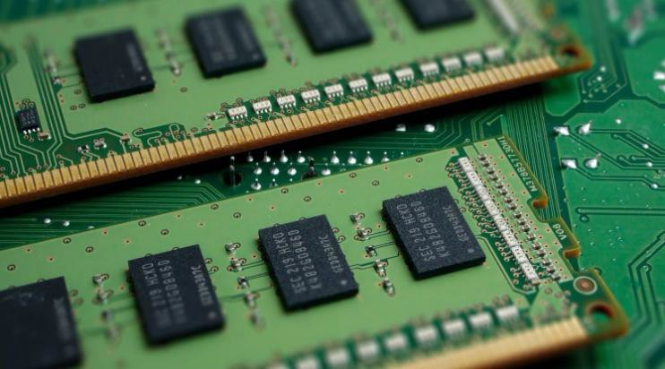

Fig 2: RAM

Generally, the faster the RAM, the faster the processing speed. With faster RAM, you increase the speed at which memory transfers information to other components. Meaning, your fast processor now has an equally fast way of talking to the other components, making your computer much more efficient

Surfing the Internet after a memory upgrade tends to be noticeably faster than before the upgrade. Web browsers load faster after a memory upgrade, regardless of Internet connection speed. In addition to web pages opening faster, a memory upgrade can also make flash content open faster. This is because the computer is using the hard drive's memory when it can't find RAM space to store data; post-upgrade, more RAM is available, making browsing faster.

1. HARD DISK:

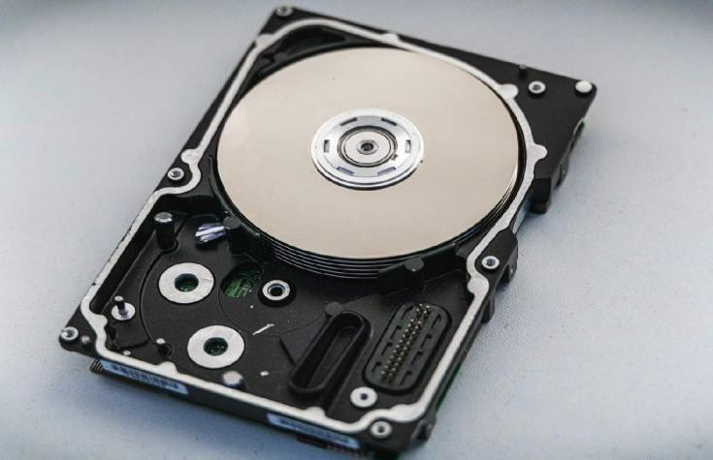

Fig 3: Hard Disk

A hard disk drive (HDD), hard disk, hard drive, or fixed disk is an electro- mechanical [data storage device](https://en.wikipedia.org/wiki/Data_storage_device) that stores and retrieves [digital data](https://en.wikipedia.org/wiki/Digital_data) using [magnetic](https://en.wikipedia.org/wiki/Magnetic_storage) [storage](https://en.wikipedia.org/wiki/Magnetic_storage) and one or more rigid rapidly rotating [platters](https://en.wikipedia.org/wiki/Hard_disk_platter) coated with magnetic material. The platters are paired with [magnetic heads,](https://en.wikipedia.org/wiki/Disk_read-and-write_head) usually arranged on a moving [actuator](https://en.wikipedia.org/wiki/Actuator) arm, which read and write data to the platter surfaces. Data is accessed in a [random-access](https://en.wikipedia.org/wiki/Random-access) manner, meaning that individual [blocks](https://en.wikipedia.org/wiki/Block_(data_storage)) of data can be stored and retrieved in any order. HDDs are a type of [non-](https://en.wikipedia.org/wiki/Non-volatile_storage) [volatile storage](https://en.wikipedia.org/wiki/Non-volatile_storage), retaining stored data even when powered off. Modern HDDs are typically in the form of a small [rectangular box.](https://en.wikipedia.org/wiki/Disk_enclosure)

1. Graphics Card:

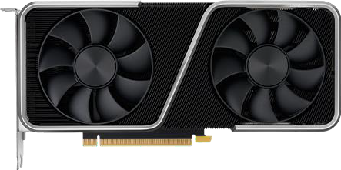

Fig 4: Graphics Card

A graphics card (also called a video card, display card, graphics adapter, GPU, VGA card/VGA, video adapter, or display adapter) is an [expansion card](https://en.wikipedia.org/wiki/Expansion_card) which generates a feed of

output images to a [display device](https://en.wikipedia.org/wiki/Display_device) (such as a [computer monitor](https://en.wikipedia.org/wiki/Computer_monitor)). Frequently, these are advertised as discrete or dedicated graphics cards, emphasizing the distinction between these and [integrated graphics.](https://en.wikipedia.org/wiki/Graphics_processing_unit#Integrated_graphics) At the core of both is the [graphics processing unit](https://en.wikipedia.org/wiki/Graphics_processing_unit) (GPU), which is the main component that performs computations, but should not be confused with the graphics card as a whole, although "GPU" is often used as a [metonymic](https://en.wikipedia.org/wiki/Metonymy) shorthand to refer to graphics cards.

* 1. SOFTWARE REQUIREMENTS
     1. LIST OF SOFTWARE REQUIREMENTS
        + Operating System: Windows 7 or above
        + Technology: Machine Learning
        + Front-end: GUI Tkinter
        + Idle: Python 2.7 or higher
     2. HARDWARE DESCRIPTION
        1. Operating System:



Fig 5: Operating Systems

An Operating System (OS) is an interface between a computer user and computer hardware. An operating system is a software which performs all the basic tasks like file management, memory management, process management, handling input and output, and controlling peripheral devices such as disk drives and printers.

An operating system is a program that acts as an interface between the user and the computer hardware and controls the execution of all kinds of programs.

* + - 1. Machine Learning:

Machine Learning is the field of study that gives computers the capability to learn without being explicitly programmed. ML is one of the most exciting technologies that one would have

ever come across. As it is evident from the name, it gives the computer that makes it more similar to humans: The ability to learn*.* Machine learning is actively being used today, perhaps in many more places than one would expect.

* + - 1. GUI Tkinter:

Tkinter is the Python interface to the Tk GUI toolkit shipped with Python. We would look this option in this chapter.

Tkinter is the standard GUI library for Python. Python when combined with Tkinter provides a fast and easy way to create GUI applications. Tkinter provides a powerful object- oriented interface to the Tk GUI toolkit.

* + - 1. Python Programming:



Fig 6: Python Programming

Python is a general-purpose interpreted, interactive, object-oriented, and high-level programming language. It was created by Guido van Rossum during 1985- 1990. Like Perl, Python source code is also available under the GNU General Public License (GPL).

## CHAPTER 4: SYSTEM DESIGN

* 1. Architectural Design:

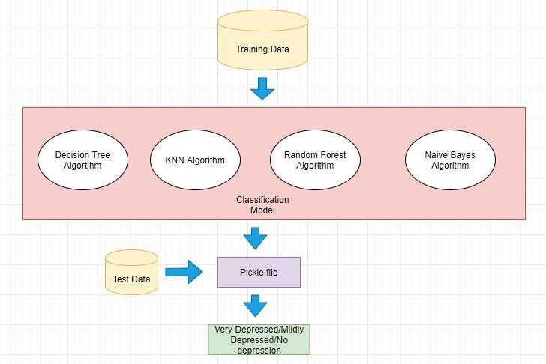The Depression Detection system under proposal has been given below. The Machine Learning model takes preprocessed training data acquired from various test subjects and generates a pickle file using various text classification algorithms. These algorithms are namely, Decision Tree algorithm, Naïve Bayes algorithm, KNN Algorithm and Random Forest Algorithm.

Fig 7: Architectural Design

The generated pickle file takes the input data fetched from the user through web application and gives out depression reading to be stored in json file. This json file is exclusive for each user and helps in generating graphical representation. The graphical representation along with conclusion is displayed to the user in end. This delivery of result is done through python web framework flask.

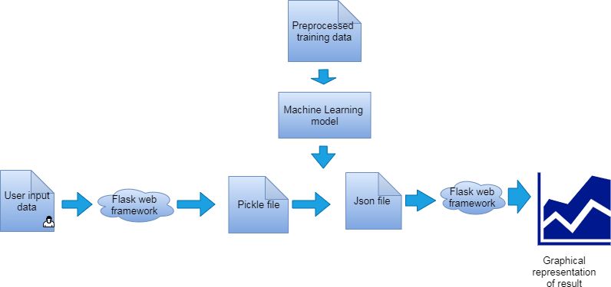

Fig 8: Data Processing

* 1. Online Depression Analysis and Detection

With the era changing, we, including the depressed users, almost cannot survive without social media. Researchers thereby started to analyze the online behaviours of depressed users. As a preliminary research, Park et al. [2012] explored the use of language in describing depressive moods utilizing real-time moods captured from Twitter users. In their follow up work, Park et al. [2013] conducted face-to-face interviews with 14 active Twitter users to explore their depressive behaviours. Recently, Xu et al. [2016] attempted to explain how web users discuss depression-related issues from the perspective of the social networks and linguistic patterns.

With the aforementioned work, depression detection via social media became possible. Choudhury et al. [2013] explored the potential of using social media to detect and diagnose major depressive disorders in individual. Resnik [2015] studied the topic models in the analysis of linguistic signals for detecting depression. These depression detection efforts demonstrated that it is possible to analyze massive depressed users on social media.

* 1. Depression Detection Approaches Used Earlier

Depression detection approaches have been proposed in many previous works using video, speech and text. Depression Recognition Sub Challenge (DSC) has been released from AVEC2013 to AVEC2018. It is evidently shown that depression of several degrees can be analysed from speech features. Correlation between depression and particular features of speech were identified by many researchers.

Experiments are performed on acoustic features – prosodic (intensity, pitch, speaking rate, loudness, pause time, jitter, energy etc.), spectral (energy spectrum density, formants, spectral energy distribution, etc.) and cepstral (MFCC and LPCC) to identify their correlation with depression. Glottal features and Teager Energy Operation (TEO) are inspected and found adequate connection with depression identification. Classification accuracy is higher in female speakers when compared to male speakers when TEO and MFCC features are considered. Few researchers illustrated the relationship between intensity of depression and speech features.

* 1. Machine Learning Approaches

Modern trend in detecting depression is using Trained machines by using speech audio, interview videos, images and text responses, etc. The digital data collected in various forms is analysed and features that are specifically related to depression are extracted. For example, in text responses or transcriptions, words that are frequently used when a person is depressed are identified. In audio data, the specific spectral or cepstral features that signify depression are identified. In video and image data, expressions, eye movement and postures are identified. Various machine learning algorithms like K Nearest neighbours (KNN), Gaussian Mixture Model(GMM), Support Vector Machine(SVM) are widely used to investigate depression using different speech types and emotions. Neural networks are used to train machines for early detection of depression using linguistic and text sequences.

* 1. Existing System

Sridharan et al. presented the detection diagnostics on online social media with the assistance of Convolution Neural Networks (CNN) where accentuation was to get information posted by different clients while also ensuring algorithm protects the security with the assistance of separating agents which deal with information. M N Stollar, M Lechh, S J Stollar, N B Allen approach utilizes an upgraded spectral move off parameters for detection of the depression side effects from discourse signals on the clinical dataset obtained. The classification of these highlights is done with the assistance of basic SVM classifier. In past investigation, gender dependence has improved depression classification either best for females, males and fluctuated amongst highlights.

* 1. Developed System

A 6-layer Convolutional Neural Network (CNN) model was employed consisting of 2 convolutional layers with max- pooling and 2 fully connected layers. Each spectrogram input is an image with dimension 513x125 representing 4 seconds of audio and frequencies ranging from 0 to 8kHz. The frequency range was tuned as a hyperparameter, since most human speech energy is concentrated between 0.3-3kHz. Each input is normalized according to decibels relative to full scale (dBFS).

Though there are some differences, the actual architecture employed in this effort was largely inspired by a paper on Environmental Sound Classification with CNNs. The network employed in this is shown in Figure 8, with DepressionDetect’s displayed in Figure 9. The CNN used here begins with an input layer being convolved with 32- 3x3 filters to create 32 feature maps followed by a ReLU activation function. Next, the feature maps undergo dimensionality reduction with a max-pooling layer, which used a 4x3 filter with a stride of 1x3. A second similar convolutional layer was employed with 32- 3x3 filters followed by a max-pooling layer with a 1x3 filter and stride of 1x3. This layer was then followed by two dense layers. After the second dense layer, a dropout layer of 0.5 was used (meaning each neuron in the second dense layer had a 50% chance of turning off after each batch update). Lastly, a softmax function is applied, which returns the probability that a spectrogram was in the depressed class or not depressed class.

The sum probabilities of each class was equal to 1. A batch size of 32 (out of 2480 spectrograms) was used along with an Adadelta optimizer, which dynamically adapted the learning rate based on the gradient.

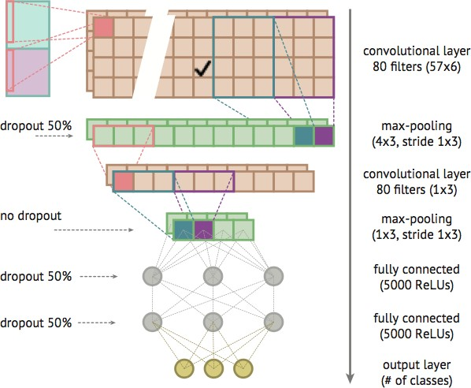

Fig 9: Environmental Sound Classification CNN architecture

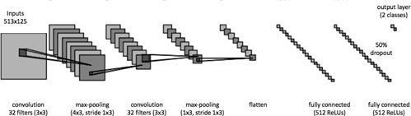

Fig 10: Depression Detect CNN architecture

## CHAPTER 5: IMPLEMENTATION

###### DATA COLLECTION

Every machine learning for sentiment analysis task starts with collection of relevant data from various sources. In this report Twitter is considered as the data source for analysis, in the form of User Tweets. This portion covers tasks from streaming the data from the Twitter servers, to compile the training and test datasets.

1. App Authentication: Application-only authentication involves communication between the application request and Twitter API, without a user context. This requires the creation of a Twitter app which is assigned a set of unique consumer key and secret key. Further to access the twitter data from incoming streams, an unique access token and secret token needs to be supplied. This two way communication is handled using the Twitter API.
2. Keyword list: Using a pre-created wordlist for detecting trigger words symbolizing poor mental well-being, Tweets from all over the world are collected at random. These keyword specific tweets are mixed with a general batch of non-weighted Tweets, in the form of JSON objects.
3. Extracting text from JSON: The collected tweets in the JSON objects are parsed to extract only the text field of the Tweets. Other meta-data related to any particular Tweet is removed.
4. Data Cleaning: To avoid errors in encoding textual data, the Text is purged for links(http) and non- ASCII characters like emoticons. Result is a clean dataset, rid of non-conformity character types.
5. Generate csv file for train and test set: The cleaned text data from individual Tweets is added to the training and test dataset, in a vectorized format. Classification labels for the training and test datasets are manually added, to create a csv file using comma as the delimiter.

###### DATA PREPROCESSING

The csv file is read and several data preprocessing steps are performed on it. Natural language processing has been utilized for preprocessing methods applied on the extracted data:

1. Tokenization: Tokenization is a process of dividing a string into several meaningfull substring,such as units of words,sentences, or themes. In this case, the first column of the csv file containing the tweet is extracted and is converted into individual tokens.
2. Stemming: Stemming involves reducing the words to their root form. This would help us to group similar words together. For implementation,Porter Stemmer is used.
3. Stop Words Removal: The commonly used words, known as stop words need to removed since they are of no use in the training and could also lead to erratic results if not ignored. Nltk library has a set of stop-words which can be used as a reference to remove stop-words from the tweet.
4. POS Tagger: To improve the quality of the training data, the tokenized text is assigned the respective parts of speech by using POS Tagger. This would be used to extract only the adjectives ,nouns and adverbs since other parts of speech are not of much significance. Example: ’I love coding’ - ’love’ being a noun is extracted, rest are removed.

After all these pre-processing steps, a bag of words is formed. Bag of words calculates the number of occurrences of each word, which is then used as a feature to train a classifier.

###### TRAINING

The classifier requires two parameters: training set and label. The training set in this case is the set of tweets which needs to be further processed in order to feed into a classifier. The set of tweets need to be converted into vector format for further processing. The set of labels corresponding to each tweet is also fed into the classifier in the form of a vector.

Saving the Classifier and the Countvectorizer Object: Since training needs to be done once, the trained classifier object needs to be loaded into a pickle file. Same is applicable with the Count Vectorizer object. Thus both these objects are dumped into a pickle file for further use.

At the researcher training stage training using a pipeline so that simplifies the calculation process. Pipeline consists of two processes, namely vectorization and Naive Bayes calculations. Here the researcher using Tf-idf vectorization to count the frequency of each word is in the training data.

After vectorization is done, then do a Naive Bayes calculation to calculate the probability of each word from both classes. At the calculation stage, researchers use Multinomial Naive Bayes (MultinomialNB).

Some of the parameters used on modeling training data is as follows:

* + - N-gram = in the range of one up to three words (1, 3).
    - α smoothing = 10, to improve model performance while minimizing misclassification.

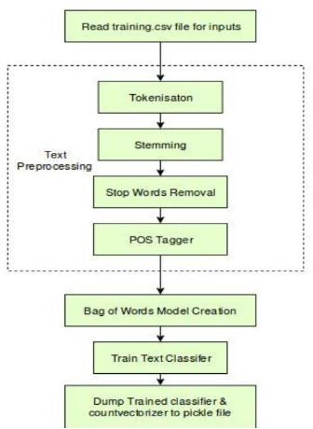

###### TESTING

Testing the classifier involves following steps:

1. Loading saved models: The trained classification models are loaded from the pickle file, to be used for prediction on test dataset.
2. Data Preprocessing: The test dataset is preprocessed in a manner similar to the training data.
3. Class Prediction: Each tweet is classified into a depressed or neutral class.
4. Computation of Confusion Matrix: Based on the values of true or false positives and negatives we compute the confusion matrix, for the evaluation of classification performance.

###### EVALUATION

The results are evaluated on the basis of F1 score and accuracy. The F1 score is the primary performance measure and accuracy is the secondary measure. F1 score is calculated based on the precision and recall.



Here, P stands for Precision and R is the Recall.

It can be noticed from the results that Multinomial Naïve Bayes has performed the best with the F1 score of 83.29 whereas SVM has achieved a lower F1 score of 79.73. The Precision and Recall follow the same trend with Multinomial Naive Bayes outperforming SVM. The normalized confusion matrix consists of two rows and two columns in which various parameters like false positives,false negatives,true positives and true negatives can be analyzed.The accuracy of the Multinomial Naive Bayes is 83% and is 79% in case of SVM.

### CHAPTER 6 : TESTING

Software and Hardware testing is a critical element of software and hardware quality assurance and represents the ultimate service of specification design, development, working and coding. It provides a road map for the developer and designer of a robot. A roadmap that describes the steps to be conducted as a path of testing, when these steps are planned and then undertaken and how much effort, time and resources will be required.

Testing demonstrates that software and hardware functions appear to be working according to specification and that performance requirements appear to have been met.

##### AIM OF TESTING

The main aim of testing is to analyse the performance and to evaluate the errors that occur when the robot’s functionality is executed. In this project, the approach involved developing incremental and systemic tests to develop the robot in a structured manner. The main aim of testing in this project is to find any issues with the robot’s function as well as its working performance.

##### TESTING PRINCIPLES

An engineer must understand the basic principles that guide testing.

1. All tests should be traceable to the final requirements.
2. Tests should be planned long before testing begins.
3. Testing should begin “in the small” and progress towards testing “in large”.

After modeling the data training is then validated using 5% testing data. Performance of the model measured based on validation score of accuracy (accuracy score), with formula as follows:

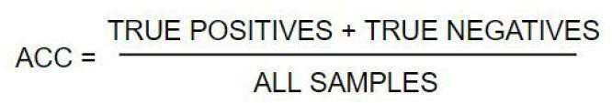

**Figure 6.1 : Accuracy Score Formula**

However, we are not only using a score of accuracy but also sensitivity (recall) and precision from the results of the classification model.

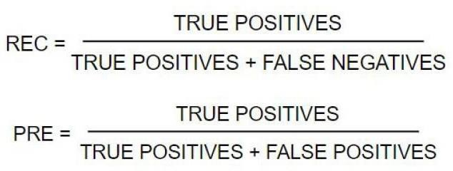

**Figure 6.2: Recall & Precision Formula**

Testing the classifier involves following steps:

1. Loading saved models: The trained classification models are loaded from the pickle file, to be used for prediction on test dataset.
2. Data Preprocessing: The test dataset is preprocessed in a manner similar to the training data.
3. Class Prediction on Browser History: Each search is classified into a depressed or neutral class.
4. Computation of Confusion Matrix: Based on the values of true or false positives and negatives we compute the confusion matrix, for the evaluation of classification performance.

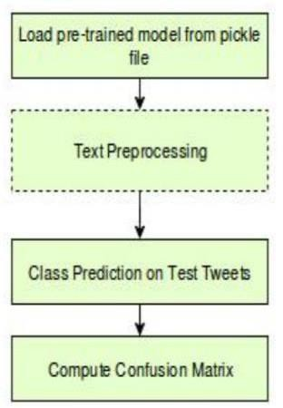

**Figure 6.3: Testing phase**

##### Test Plan

A test plan is a document that contains a complete set of test cases for a system, along with other information about the testing process. The test plan should be returned long before the testing starts. Test plan identifies

1. A task set to be applied as testing commences.
2. The work products to be produced as each testing task is executed.
3. The manner in which the results of testing are evaluated and recorded.

## CHAPTER 7: OUTPUT

For a better understanding of the general intuition behind depression, in this paper, we applied NLP, TF-ID and Ensemble classifier techniques for depression detection of emotional terms. We showed that all of these classification techniques based on linguistic style, emotional process, temporal process and all (Linguistic, emotional and temporal) features are able to successfully extract the depressive emotional result. It can be observed that NLP gives a better outcome. We believe that the current study has laid the ground for future research on inferences and discovery of additional information based on cause-event relation, such as detection of implicit emotion or cause, as well as prediction of public opinion based on cause events, etc. Moreover, in this paper, we applied many types of attributes of the NLP Algorithm for detecting depression, but we can still apply more attributes. Though we achieved accuracy between 60 and 80%; there is still some room for improvement. It is important to note that this study does not identify who the sufferers are; but assess the browser history for depression detection.

The results show that the system and code has performed well as per the requirements.

* + Monitor your Depression Levels

This depression detection browser extension helps in detecting the depression level of a person using the browser by taking the browsing history and showing the level of depression in the range of 1 to 5. 1 means the worst level of depression and 5 means least depression.

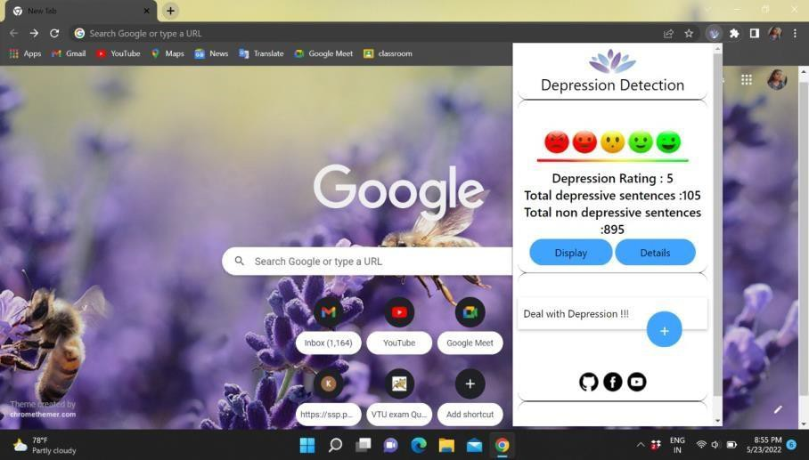

* + Suggests soothing music

Music therapy offers people a creative and accessible way of expressing their feelings and processing their experiences. People have used music for its powerful effects on mood and emotions for a long time. Aside from helping with mental health conditions, music therapy also has numerous other benefits, such as providing a creative outlet, expanding knowledge and cultural awareness, and improving cognitive skills such as memory.

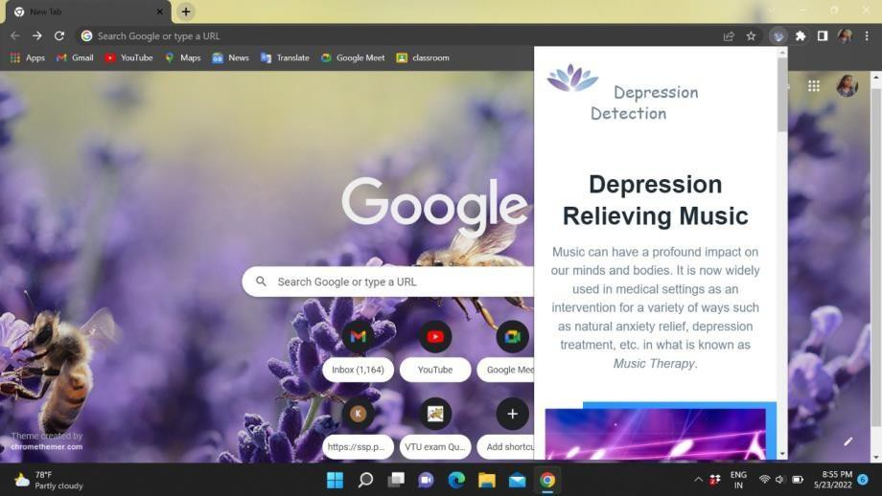

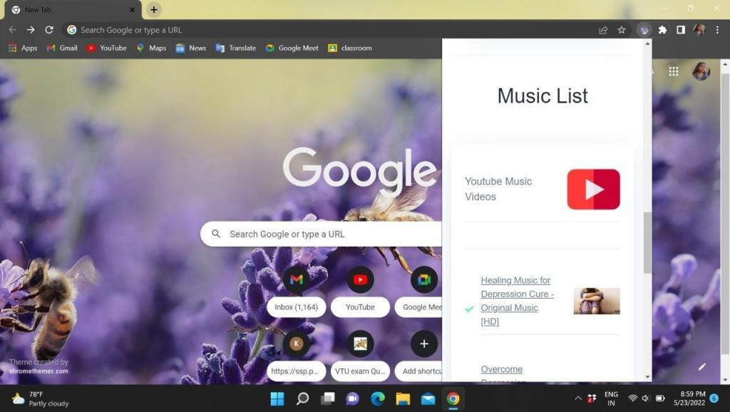

* + Therapy ChatBots

Therapy bots are basically chatbots which can provide online therapy, using the rules of emotional reasoning and Artificial Intelligence. But then, the inevitable question in everyone's mind is- “Is it possible to automate the expertise needed to become an effective therapist?” Well, the responses in these chatbots mainly comprises two elements. In some instances, the responses are based on Machine Learning. In some, there’s a human element involved. When automation and human assistance work together, the online therapy bot can nurture and assist patients in a better manner.

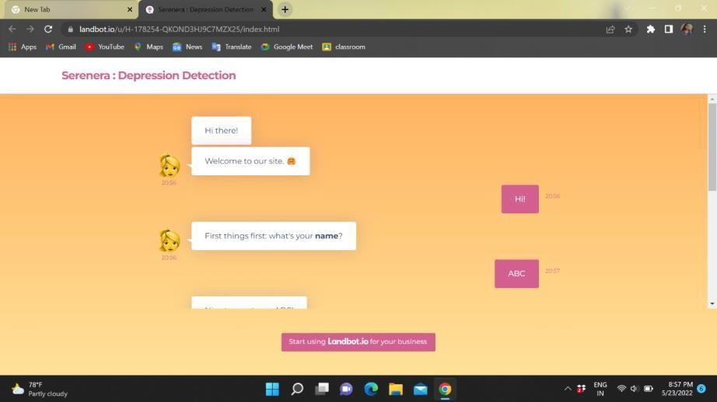

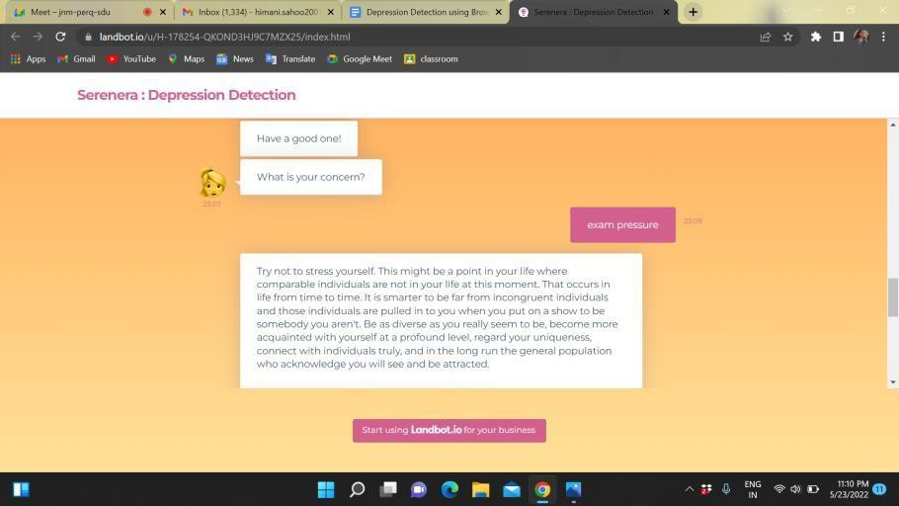

* + Suggests your nearest Psychiatrist

A psychiatrist is a medical physician who specializes in the care and treatment of mental, emotional, and addictive disorders. A psychiatrist is involved in the prevention, diagnosis, and treatment of mental diseases like anxiety, depression, psychosis, substance abuse, sexual dysfunction, and developmental disabilities.

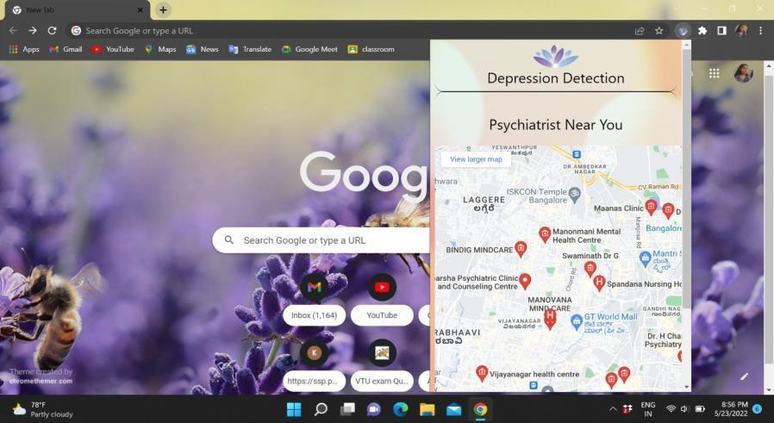

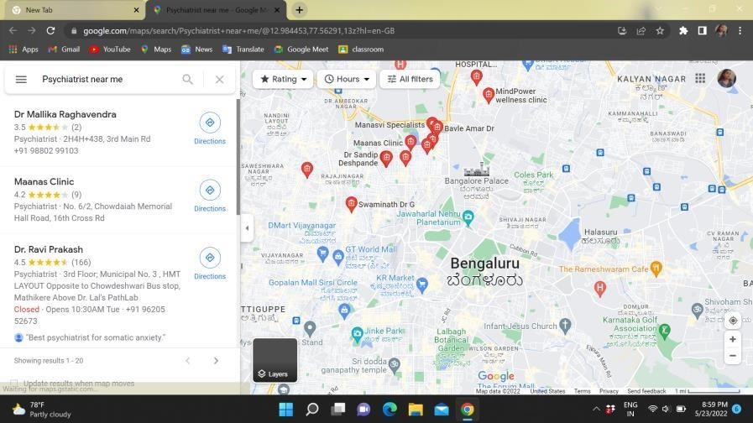

## CHAPTER 8: CONCLUSION

We are developing a browser extension to detect depression at early stages using machine learning. Proposed network can detect depression at early stages. The method can find applications in improving mental health issues faced by humans in everyday life. Also an approach to improve day to day life habits.

The following are the results obtained from this work : This system gives us a large amount of related data for the analysis of depression symptoms extraction. We have used the browser history generated from twitter for the analysis. Then we calculated the scores and correlated it with symptoms. And later we will give this data to the hospital which enables medical professionals to assess the state of the patient in a better way. In summary, we studied three types of factors (emotional process, temporal process, linguistic style) and trained a model to utilize each type of factor independently and jointly. We use machine learning techniques to classify the features of comments. Our findings showed that all of the classifiers results are almost between 60 and 80% .

Proposed system aims at reducing physical intervention of human beings in the process of detecting depression in an individual. Previously, one had to look up to human doctors to identify depression through standardized methods. On the other hand, our application automates this procedure, and quickly provides us with a diagnostic report in private. The provided diagnostic comes with high accuracy, owing to the large dataset on which model has been trained upon.

## CHAPTER 9: FUTURE IMPROVEMENTS

In future, we are intrigued to expand the work with some profound learning models, for example, Neural Networks or convolution neural networks or the use of stacked LSTMs coupled with CNN. We plan to go beyond mobility features and explore detecting depression using smartphone-sensed data types and modalities including voice, social interactions, smartphone communication patterns, and browsing patterns. We also plan to apply our approach to smartphone sensing of other ailments such as Traumatic Brain Injury (TBI or concussions) and infectious diseases.

We plan to explore the robustness of our approach by applying it to depression data gathered from other user populations. We can create a model that can more accurately identify depression, benefiting people all across the world. People may suffer from anxiety, depression, or suicide thoughts, and we can predict the same using AI and machine learning techniques.

Developing a system that can identify depressive behavior in persons who do not use Technology is a research objective in the future. We have decided to make our own chatbot in the near future. We will also make it compatible to be used in internet explorer as well as in smart phone.

## 

## CHAPTER 10: BIBLIOGRAPHY

1. B. Verma, S. Gupta, and L. Goel, “A neural network based hybrid model for depression detection in twitter,” in *Proceedings of the International Conference on Advances in Computing and Data Sciences*, pp. 164–175, Springer, Valletta, Malta, April 2020. View at: [Publisher Site |](https://doi.org/10.1007/978-981-15-6634-9_16) [Google Scholar](https://scholar.google.com/scholar_lookup?title=A%20neural%20network%20based%20hybrid%20model%20for%20depression%20detection%20in%20twitter&author=B.%20Verma&author=S.%20Gupta&author&author=L.%20Goel)
2. M. De Choudhary, F. A. Bakar, and N. M. Nawi, “Predicting depression using social media posts,” *Journal of Soft Computing and Data Mining*, vol. 2, no. 2, pp. 39–48, 2021. View at: [Google Scholar](https://scholar.google.com/scholar_lookup?title=Predicting%20depression%20using%20social%20media%20posts&author=M.%20De%20Choudhary&author=F.%20A.%20Bakar&author&author=N.%20M.%20Nawi&publication_year=2021)

M. M. Mariani, P. V. Rodrigo, and W. Jochen, “AI in Marketing, Consumer Research and Psychology: A Systematic Literature Review and Research Agenda,” *Psychology & Marketing*, vol. 39, no. 4, 2021. View at: [Publisher Site |](https://doi.org/10.1002/mar.21619) [Google Scholar](https://scholar.google.com/scholar_lookup?title=AI%20in%20Marketing%2C%20Consumer%20Research%20and%20Psychology%3A%20A%20Systematic%20Literature%20Review%20and%20Research%20Agenda&author=M.%20M.%20Mariani&author=P.%20V.%20Rodrigo&author&author=W.%20Jochen&publication_year=2021)

1. J. A. Naslund, T. Deepak, A. Aditya et al., “Digital training for non-specialist health workers to deliver a brief psychological treatment for depression in India: Protocol for a three-arm randomized controlled trial,” *Contemporary Clinical Trials*, vol. 102, Article ID 106267, 2021. View at: [Publisher Site |](https://doi.org/10.1016/j.cct.2021.106267) [Google Scholar](https://scholar.google.com/scholar_lookup?title=Digital%20training%20for%20non-specialist%20health%20workers%20to%20deliver%20a%20brief%20psychological%20treatment%20for%20depression%20in%20India%3A%20Protocol%20for%20a%20three-arm%20randomized%20controlled%20trial&author=J.%20A.%20Naslund&author=T.%20Deepak&author=A.%20Aditya%20et%20al.&publication_year=2021)
2. Y. R. Tausczik and J. W. Pennebaker, “The psychological meaning of words: LIWC and computerized text analysis methods,” *Journal of Language and Social Psychology*, vol. 29, no. 1, pp. 24–54, 2010. View at: [Publisher Site |](https://doi.org/10.1177/0261927x09351676) [Google Scholar](https://scholar.google.com/scholar_lookup?title=The%20psychological%20meaning%20of%20words%3A%20LIWC%20and%20computerized%20text%20analysis%20methods&author=Y.%20R.%20Tausczik%20&author=J.%20W.%20Pennebaker&publication_year=2010)
3. J. W. Pennebaker, M. E. Francis, and R. J. Booth, *Linguistic inquiry and word count: LIWC 2001*, Lawrence Erlbaum Associates, Mahway, vol. 71, 2001.
4. J. W. Pennebaker, R. L. Boyd, J. Kayla, and B. Kate, *The Development and Psychometric Properties of LIWC2015*, University of Texas at Austin, Austin, TX, 2015.
5. Md R. Islam, A. R. M. Kamal, N. Sultana, R. Islam, and M. A. Moni, “Detecting depression using k-nearest neighbors (knn) classification technique,” in *Proceedings of the International Conference on Computer, Communication, Chemical, Material and Electronic Engineering (IC4ME2)*, pp. 1–4, IEEE, Rajshahi, Bangladesha, February 2018. View at: [Publisher Site |](https://doi.org/10.1109/ic4me2.2018.8465641) [Google Scholar](https://scholar.google.com/scholar_lookup?title=Detecting%20depression%20using%20k-nearest%20neighbors%20(knn)%20classification%20technique&author=Md%20R.%20Islam&author=A.%20R.%20M.%20Kamal&author=N.%20Sultana&author=R.%20Islam&author&author=M.%20A.%20Moni)
6. G. Li, B. Li, L. Huang, and S. Hou, “Automatic construction of a depression-domain lexicon based on microblogs: text mining study,” *JMIR medical informatics*, vol. 8, no. 6, Article ID e17650, 2020. View at: [Publisher Site |](https://doi.org/10.2196/17650) [Google Scholar](https://scholar.google.com/scholar_lookup?title=Automatic%20construction%20of%20a%20depression-domain%20lexicon%20based%20on%20microblogs%3A%20text%20mining%20study&author=G.%20Li&author=B.%20Li&author=L.%20Huang&author&author=S.%20Hou&publication_year=2020)
7. H. Al, M. Ghassemi, and J. R. Glass, “Detecting depression with audio/text sequence modeling of interviews,” in *Proceedings of the Interspeech*, pp. 1716–1720, Hyderabad, September 2018. View at: [Publisher Site](https://doi.org/10.21437/interspeech.2018-2522) | Google Scholar
8. M. Nadeem, “Identifying depression on twitter,” July 2016, <https://arxiv.org/abs/1607.07384>. View at: [Google](https://scholar.google.com/scholar_lookup?title=Identifying%20depression%20on%20twitter&author=M.%20Nadeem&publication_year=July%202016) [Scholar](https://scholar.google.com/scholar_lookup?title=Identifying%20depression%20on%20twitter&author=M.%20Nadeem&publication_year=July%202016)
9. M. Trotzek, S. Koitka, M. Christoph, and Friedrich, “Utilizing neural networks and linguistic metadata for early detection of depression indications in text sequences,” *IEEE Transactions on Knowledge and Data Engineering*, vol. 32, no. 3, pp. 588–601, 2018. View at: [Google Scholar](https://scholar.google.com/scholar_lookup?title=Utilizing%20neural%20networks%20and%20linguistic%20metadata%20for%20early%20detection%20of%20depression%20indications%20in%20text%20sequences&author=M.%20Trotzek&author=S.%20Koitka&author=M.%20Christoph&author&author=%20Friedrich&publication_year=2018)
10. Md R. Islam, M. A. Kabir, A. Ahmed, A. R. M. Kamal, H. Wang, and A. Ulhaq, “Depression detection from social network data using machine learning techniques,” *Health Information Science and Systems*, vol. 6, no. 1, pp. 1–12, 2018. View at: [Publisher Site |](https://doi.org/10.1007/s13755-018-0046-0) [Google Scholar](https://scholar.google.com/scholar_lookup?title=Depression%20detection%20from%20social%20network%20data%20using%20machine%20learning%20techniques&author=Md%20R.%20Islam&author=M.%20A.%20Kabir&author=A.%20Ahmed&author=A.%20R.%20M.%20Kamal&author=H.%20Wang&author&author=A.%20Ulhaq&publication_year=2018)
11. B. Zohuri and S. Zadeh, “The utility of artificial intelligence for mood analysis, depression detection, and suicide risk management,” *Journal of Health Science*, vol. 8, pp. 67–73, 2020. View at: [Publisher Site |](https://doi.org/10.17265/2328-7136/2020.02.003) [Google](https://scholar.google.com/scholar_lookup?title=The%20utility%20of%20artificial%20intelligence%20for%20mood%20analysis%2C%20depression%20detection%2C%20and%20suicide%20risk%20management&author=B.%20Zohuri%20&author=S.%20Zadeh&publication_year=2020) [Scholar](https://scholar.google.com/scholar_lookup?title=The%20utility%20of%20artificial%20intelligence%20for%20mood%20analysis%2C%20depression%20detection%2C%20and%20suicide%20risk%20management&author=B.%20Zohuri%20&author=S.%20Zadeh&publication_year=2020)
12. J. Li, Q. Zhu, Q. Wu, and Z. Fan, “A novel oversampling technique for class-imbalanced learning based on SMOTE and natural neighbors,” *Information Sciences*, vol. 565, pp. 438–455, 2021. View at: [Publisher Site |](https://doi.org/10.1016/j.ins.2021.03.041) [Google Scholar](https://scholar.google.com/scholar_lookup?title=A%20novel%20oversampling%20technique%20for%20class-imbalanced%20learning%20based%20on%20SMOTE%20and%20natural%20neighbors&author=J.%20Li&author=Q.%20Zhu&author=Q.%20Wu&author&author=Z.%20Fan&publication_year=2021)
13. O. Asare Kennedy, Y. Terhorst, J. Vega, E. Peltonen, E. Lagerspetz, and D. Ferreira, “Predicting depression from smartphone behavioral markers using machine learning methods, hyperparameter optimization, and feature importance analysis: exploratory study,” *JMIR mHealth and uHealth*, vol. 9, no. 7, Article ID e26540, 2021. View at: [Publisher Site |](https://doi.org/10.2196/26540) [Google Scholar](https://scholar.google.com/scholar_lookup?title=Predicting%20depression%20from%20smartphone%20behavioral%20markers%20using%20machine%20learning%20methods%2C%20hyperparameter%20optimization%2C%20and%20feature%20importance%20analysis%3A%20exploratory%20study&author=O.%20Asare%20Kennedy&author=Y.%20Terhorst&author=J.%20Vega&author=E.%20Peltonen&author=E.%20Lagerspetz&author&author=D.%20Ferreira&publication_year=2021)
14. M. Tadalagi and A. M. Joshi, “AutoDep: Automatic Depression Detection Using Facial Expressions Based on Linear Binary Pattern Descriptor,” *Medical & Biological Engineering & Computing*, vol. 59, no. 6, pp. 1– 16, 2021. View at: [Publisher Site |](https://doi.org/10.1007/s11517-021-02358-2) [Google Scholar](https://scholar.google.com/scholar_lookup?title=AutoDep%3A%20Automatic%20Depression%20Detection%20Using%20Facial%20Expressions%20Based%20on%20Linear%20Binary%20Pattern%20Descriptor&author=M.%20Tadalagi%20&author=A.%20M.%20Joshi&publication_year=2021)
15. T. Nguyen, P. Dinh, Bo Dao, S. Venkatesh, and M. Berk, “Affective and content analysis of online depression communities,” *IEEE Transactions on Affective Computing*, vol. 5, no. 3, pp. 217–226, 2014. View at: [Publisher Site |](https://doi.org/10.1109/taffc.2014.2315623) [Google Scholar](https://scholar.google.com/scholar_lookup?title=Affective%20and%20content%20analysis%20of%20online%20depression%20communities&author=T.%20Nguyen&author=P.%20Dinh&author=Bo%20Dao&author=S.%20Venkatesh&author&author=M.%20Berk&publication_year=2014)
16. M. Gaikar, J. Chavan, K. Indore, and R. Shedge, “Depression detection and prevention system by analysing tweets,” in *Proceedings of the 2019: Conference on Technologies for Future Cities (CTFC)*, Panvel, January 2019. View at: [Google Scholar](https://scholar.google.com/scholar_lookup?title=Depression%20detection%20and%20prevention%20system%20by%20analysing%20tweets&author=M.%20Gaikar&author=J.%20Chavan&author=K.%20Indore&author&author=R.%20Shedge)
17. L. He and C. Cui, “Automated depression analysis using convolutional neural networks from speech,” *Journal of Biomedical Informatics*, vol. 83, pp. 103–111, 2018. View at: [Publisher Site |](https://doi.org/10.1016/j.jbi.2018.05.007) [Google Scholar](https://scholar.google.com/scholar_lookup?title=Automated%20depression%20analysis%20using%20convolutional%20neural%20networks%20from%20speech&author=L.%20He%20&author=C.%20Cui&publication_year=2018)
18. W. Li, Q. Wang, X. Liu, and Y. Yu, “Simple action for depression detection: using kinect-recorded human kinematic skeletal data,” *BMC Psychiatry*, vol. 21, no. 1, pp. 1–11, 2021. View at: [Publisher Site](https://doi.org/10.1186/s12888-021-03184-4) | [Google](https://scholar.google.com/scholar_lookup?title=Simple%20action%20for%20depression%20detection%3A%20using%20kinect-recorded%20human%20kinematic%20skeletal%20data&author=W.%20Li&author=Q.%20Wang&author=X.%20Liu&author&author=Y.%20Yu&publication_year=2021) [Scholar](https://scholar.google.com/scholar_lookup?title=Simple%20action%20for%20depression%20detection%3A%20using%20kinect-recorded%20human%20kinematic%20skeletal%20data&author=W.%20Li&author=Q.%20Wang&author=X.%20Liu&author&author=Y.%20Yu&publication_year=2021)
19. J. Ah-Pine and E. P. Soriano-Morales, “A Study of Synthetic Oversampling for Twitter Imbalanced Sentiment Analysis,” in *Proceedings of the Workshop on Interactions between Data Mining and Natural Language Processing DMNLP*, SKOPJE, Macedonia, September 2016. View at: [Google Scholar](https://scholar.google.com/scholar_lookup?title=A%20Study%20of%20Synthetic%20Oversampling%20for%20Twitter%20Imbalanced%20Sentiment%20Analysis&author=J.%20Ah-Pine%20&author=E.%20P.%20Soriano-Morales)
20. D. Elreedy and A. F. Atiya, “A comprehensive analysis of synthetic minority oversampling technique (SMOTE) for handling class imbalance,” *Information Sciences*, vol. 505, pp. 32–64, 2019. View at: [Publisher](https://doi.org/10.1016/j.ins.2019.07.070) [Site |](https://doi.org/10.1016/j.ins.2019.07.070) [Google Scholar](https://scholar.google.com/scholar_lookup?title=A%20comprehensive%20analysis%20of%20synthetic%20minority%20oversampling%20technique%20(SMOTE)%20for%20handling%20class%20imbalance&author=D.%20Elreedy%20&author=A.%20F.%20Atiya&publication_year=2019)
21. A. H. Uddin, D. Bapery, and A. S. M. Arif, “Depression analysis from social media data in Bangla language using long short term memory (LSTM) recurrent neural network technique,” in *Proceedings of the 2019 International Conference on Computer, Communication, Chemical, Materials and Electronic Engineering( IC4ME2)*, pp. 1–4, IEEE, Rajshahi, Bangladesh, July 2019. View at: [Google Scholar](https://scholar.google.com/scholar_lookup?title=Depression%20analysis%20from%20social%20media%20data%20in%20Bangla%20language%20using%20long%20short%20term%20memory%20(LSTM)%20recurrent%20neural%20network%20technique&author=A.%20H.%20Uddin&author=D.%20Bapery&author&author=A.%20S.%20M.%20Arif)

-